BIT4139: ETHICAL HACKING

STUDENT DETAILS
STUDENT NAME: JESSICA ANNE OMONDI
ADM NUMBER: BSCCS/32081/2024
COURSE: COMPUTER SCIENCE
UNIT CODE: BIT 4139

UNIT NAME: ETHICAL HACKING
LECTURER NAME: MICHAEL NYORO
SEMESTER/ACADEMIC YEAR: 2025/2026

Contents
INTRODUCTION 3
INSTALLATION OF TOOLS 3
PENTESTING ON MY NETWORK THROUGH MY ROUTER 5
Foot Printing Setup 5
Foot Printing 5
Port Scanning 6
Service Detection 6
DNS Foot Printing 7
Vulnerability scanning 7
Student Reflection 8
WEEK 6 ASSIGNMENT 8
Information gathering 8
Identify a target 8
2.IP RESOLUTION 9
3.PORT SCAN 10
4.SUBDOMAIN 10
5.TECHNOLOGIES IDENTIFICATION 11
B. SCANNING AND ENUMERATION 11
1.Vulnerability scanning 11
Student Reflection 11

INTRODUCTION

INSTALLATION OF TOOLS

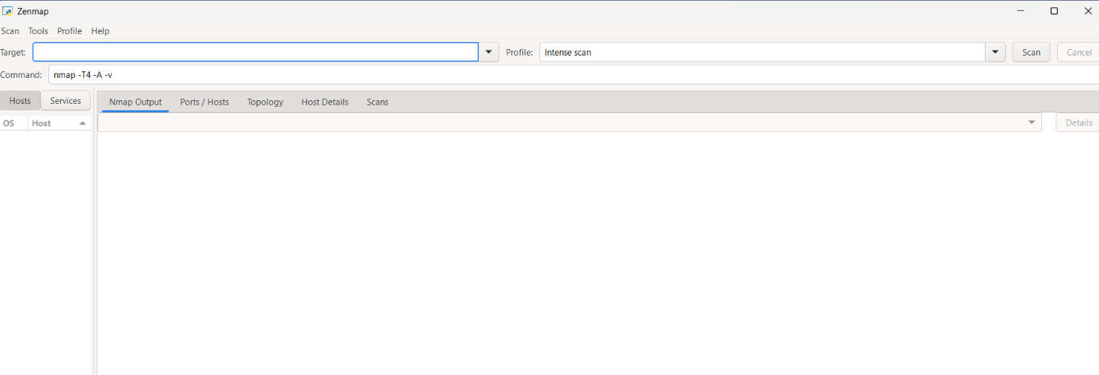
Figure 1shows Nmap is installed in my machine

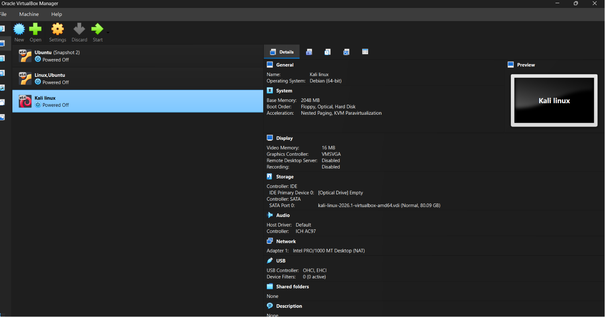
Figure 2shows installation of Oracle Virtual Machine installed in my computer

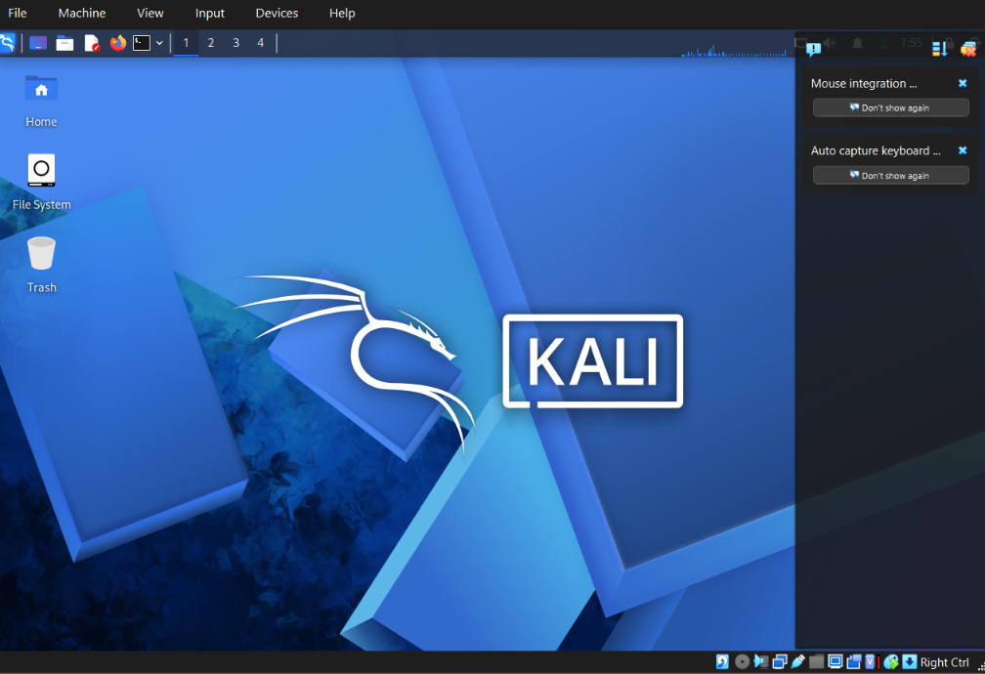
Figure 3shows Kali Linux running in my Virtual Machine as the OS

PENTESTING ON MY NETWORK THROUGH MY ROUTER

Foot Printing Setup

This step helps us set up for foot printing by finding the network(ipconfig)
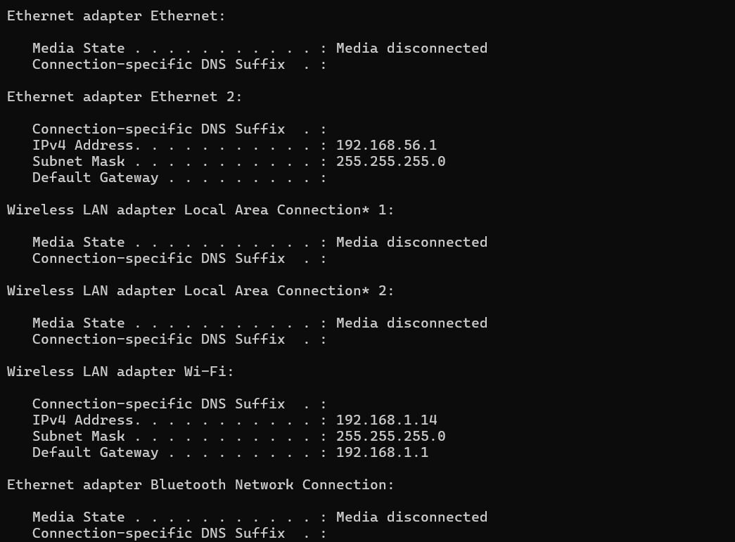
Figure 4shows output of ping command
The foot printing process identified the active IP address (192.168.1.14) and default gateway (192.168.1.1), which represents the target router for further network analysis.
This information is important in foot printing as it helps map the network structure and identify the target device (router) for further scanning and analysis.

Foot Printing
This step helps us discover devices typically asking who is connected to my wi-fi?(Nmap -sn 192.168.1.0/24)
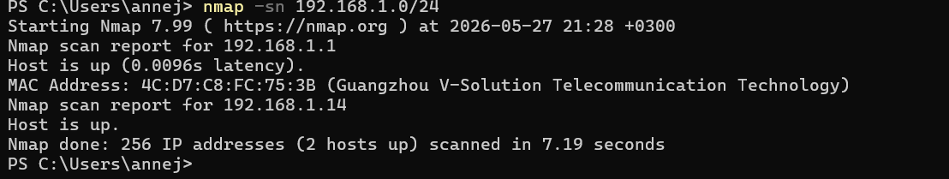
Figure 5Network discovery scan using Nmap (192.168.1.0/24 subnet).
The figure shows a network foot printing scan performed using the Nmap tool with the -sn (ping scan) option on the local subnet 192.168.1.0/24. The scan was used to identify active hosts within the network without performing a port scan.
From the results, two active devices were discovered: 192.168.1.1 (likely the router/gateway) and 192.168.1.14. The MAC address of the gateway was also revealed, including the vendor information (Guangzhou V-Solution Telecommunications Technology), which helps in identifying the type of device on the network.
This type of scan is part of foot printing (reconnaissance phase) fin cybersecurity, where an attacker or security analyst maps out live hosts in a network before further analysis such as port scanning or vulnerability assessment.

Port Scanning
This is technically looking for which port are open in a router using Nmap -p- 192.168.1.1
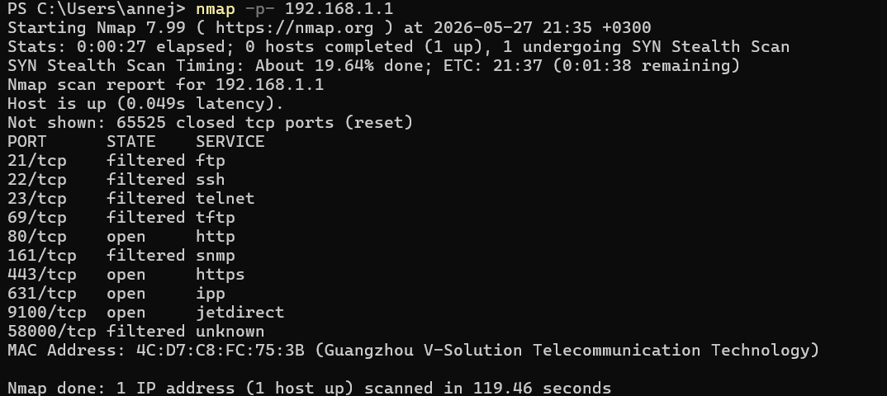
Figure 6Nmap scan of 192.168.1.1 showing open, filtered, and closed TCP ports.

An Nmap SYN stealth scan of 192.168.1.1 (MAC: Guangzhou V-Solution, likely a router) shows four open ports — 80 (HTTP), 443 (HTTPS), 631 (IPP), and 9100 (Jet Direct) — indicating web and printing services are accessible. Six ports are filtered (21, 22, 23, 69, 161, 58000), suggesting a firewall is dropping traffic to common administrative and file transfer services. All other TCP ports returned closed.

Service Detection
Service detection identifies exactly which software and version is running on an open port (e.g., "Apache 2.4.52" instead of just "port 80"). This helps with vulnerability assessment, verifying configurations, and planning targeted attacks or fixes.
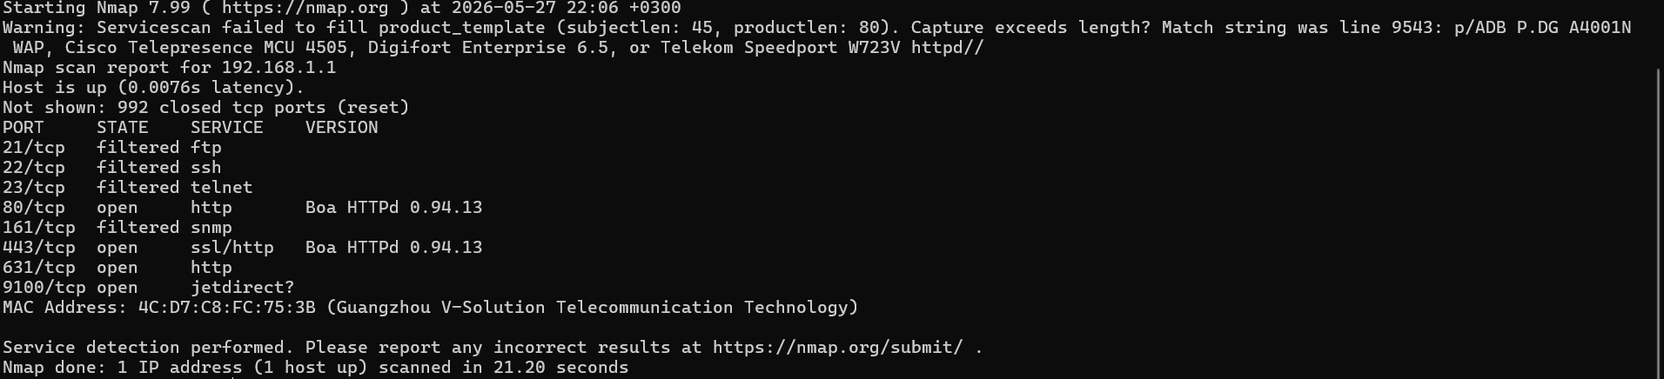
Figure 7Service Detection results
The scan reveals that 192.168.1.1 is a router-like device running Boa HTTPd 0.94.13 on ports 80 and 443, with additional printing services on 631 and 9100. Filtered ports indicate a firewall is blocking access to FTP, SSH, Telnet, and SNMP, while all other TCP ports are closed.

DNS Foot Printing

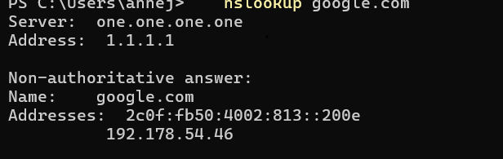
Figure 8DNS foot printing

Vulnerability scanning
This scan is important because it identifies missing HTTP security headers that can lead to attacks like SSL stripping (no HSTS) or clickjacking (no X-Frame-Options). Fixing these misconfigurations helps protect users and sensitive data.

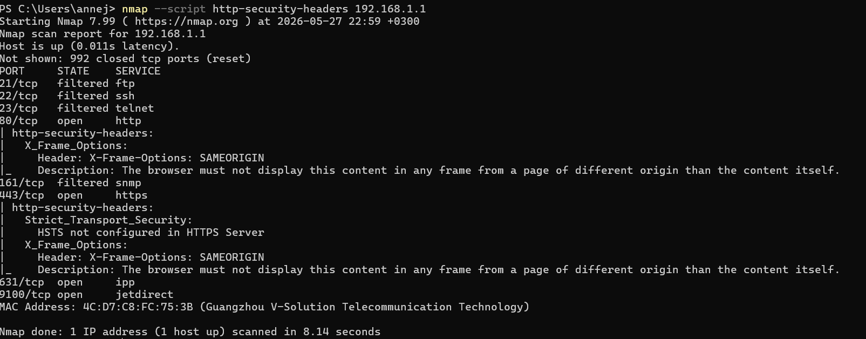
Figure 9Figure X: Nmap http-security-headers script scan of 192.168.1.1 showing X-Frame-Options configured on ports 80 and 443, but HSTS missing on port 443.

Student Reflection
In this exercise, I performed foot -printing, port scanning, service detection, DNS analysis, and vulnerability scanning on my local network router. I was able to identify active devices, open ports, and running services, as well as some basic security configurations.
The results showed that some services were exposed while others were protected by firewall filtering, and a missing security header (HSTS) was also identified. Overall, this activity improved my understanding of network reconnaissance and highlighted the importance of securing network devices.

WEEK 6 ASSIGNMENT

Information gathering

Identify a target
Identify a target which in this case is Nmap which is authorized and access has been granted
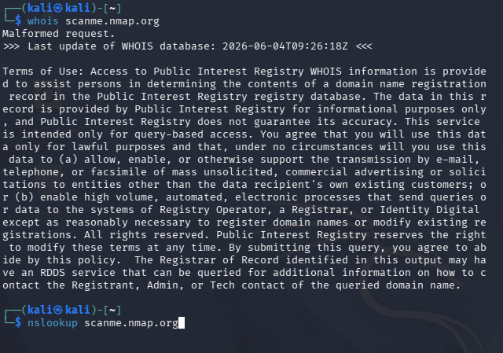
Figure 10 shows my target organization

2.IP RESOLUTION

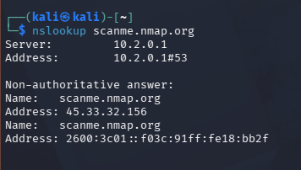
Figure 11IP resolution findings

3.PORT SCAN
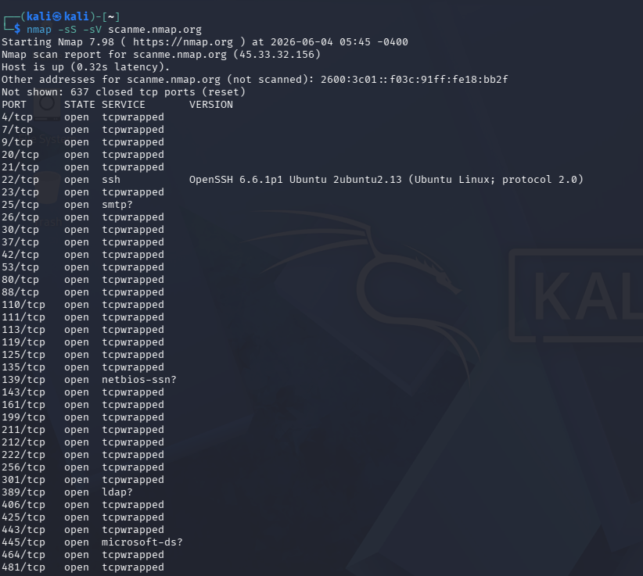
Figure 12shows a port scan of nmap.org and open services at the moment

4.SUBDOMAIN
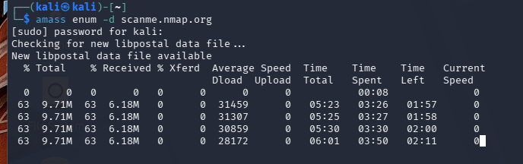
Figure 13 subdomain scanning of nmap.org

5.TECHNOLOGIES IDENTIFICATION
Figure 14shows technologies used in nmap.org. For example, Apache, Ubuntu Linux.

B. SCANNING AND ENUMERATION

1.Vulnerability scanning
This scan is important because it identifies missing HTTP security headers that can lead to attacks like SSL stripping (no HSTS) or clickjacking (no X-Frame-Options). Fixing these misconfigurations helps protect users and sensitive data.



Student Reflection
During this activity, I was able to successfully identify open ports, running services, operating system information, users, shared folders, and potential vulnerabilities on the authorized target system. The findings showed how much information can be gathered from a system through reconnaissance and enumeration techniques.
This exercise helped me understand the importance of securing exposed services and regularly monitoring systems for vulnerabilities. It also improved my practical skills in using cybersecurity tools and interpreting their results. Overall, the activity provided valuable hands-on experience and increased my understanding of network security assessments.

